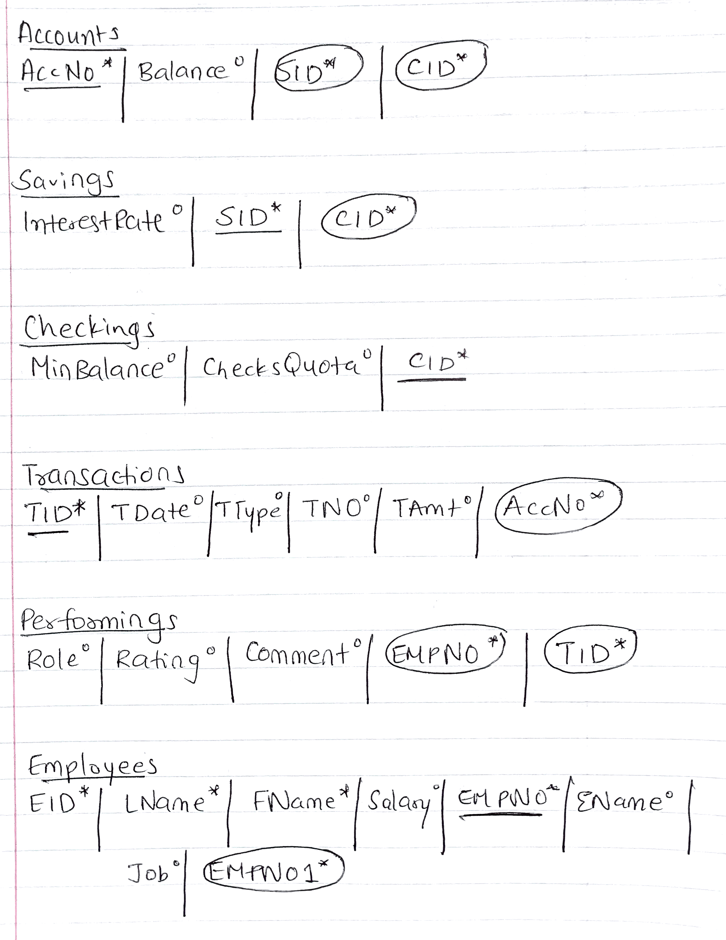

SQL Code

drop table accounts cascade constraints;
create table accounts (
Accno number (12) not null,
balance number (5,2),
SID number (12) not null,
CID number (12) not null,
constraint pk_acc primary key(Accno),
constraint fk_acc_sav foreign key (SID) references savings,
constraint fk_acc_che foreign key (CID) references checkings
);

drop table savings cascade constraints;
create table savings (
InterestRate number(2,2),
SID number (12) not null,
CID number (12) not null,
constraint pk_sav primary key (SID),
constraint fk_sav_che foreign key (CID) references checkings
);

drop table checkings cascade constraints;
create table checkings (
MinBalance number (3,2),
ChecksQuota char(20),
CID number (12) not null,
constraint pk_che primary key (CID)
);

drop table transactions cascade constraints;
create table transactions (
TID number (7) not null,
TDate date,
TType char (20),
TNO number (9),
TAccount char(10),
Accno number (12) not null,
constraint pk_tran primary key (TID),
constraint fk_tran_acc foreign key (Accno) references accounts
);

drop table employees1 cascade constraints;
create table employees1 (
EID number (9) not null,
Lname char (20) not null,
Fname char (35),
Salary number (6,2),
EMPNO number (7) not null,
ENAME char (20),
Job char (30),
EMPNO1 number (7),
constraint pk_emp primary key (EMPNO),
constraint fk_emp_emp foreign key (EMPNO1) references employees1
);

drop table performings cascade constraints;
create table performings(
Role char (20),
Rating number (1,1),
Comment varchar (500),
EMPNO number (7) not null,
TID number (7) not null,
constraint fk_per_emp foreign key (EMPNO) references employees1,
constraint fk_per_tran foreign key (TID) references transactions
);

